**Unit 3 Review**

Read each question carefully. Don’t forget to include details and correct math vocabulary in any questions with explanations.

1. How do you know if two figures are similar?

Two figures are similar if the corresponding angles are congruent and the corresponding sides are in proportion.

1. Are dilated images congruent to their corresponding pre-image? Why or why not?

No. Dilating changes the size. In order to be congruent, they would have to be the same size.

1. Is figure A similar to figure A’? Explain how you know.



Yes, they are similar. All angles are 90 degrees and a scale factor of ½ has been applied to all side lengths.

1. How do you find a dilation’s scale factor . . .
   1. if the figures are NOT on a coordinate plane?

Make a ratio of the image length to the pre-image length and simplify.

* 1. if the figures ARE on a coordinate plane?

Make a ratio of corresponding coordinates (only x or y is needed) and simplify.

1. Are the two triangles similar? Give a detailed explanation regarding why or

why not.

**Yes. Even though we don’t know the length of the sides, the corresponding angles are congruent. Both triangles share angle R, and angle S corresponds to angle P and angle T corresponds to angle Q and they are congruent. Therefore the corresponding sides would also be proportional meaning they would have equivalent ratios.**

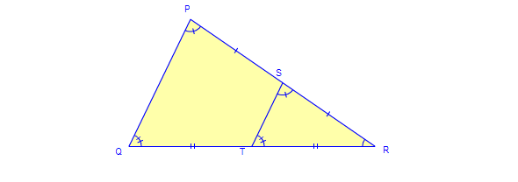

1. A building casts a shadow that is 32 feet long. A toddler who is 2 feet 3 inches tall casts a shadow 4 feet long. How tall is the building? Set up a proportion to solve.

 (You can changes feet to inches or inches to feet.)

The building is 18 feet tall.

1. Give an example of a scale factor that would reduce the size of the pre-image.

*(answers will vary, but any number between 0 and 1 would work)*

8. Are the two figures similar? How do you know?

No, they are not similar because the

sides are not in proportion.

1. What is 45% of 90?

 x = 40.5

1. 76 is what percent of 50?

 x = 152%

1. 30% of what number is 20?

 x = 66.6666 . . . or 66 2/3 or 66.7

1. John went to Men’s Warehouse to buy a tie. The tie was originally $45 but was on sale for 20% off. He also had a Frequent Flyer coupon for an additional 15% off.
   1. How much was his tie after the first discount?

$36 *(you had to take OFF the 20% or pay 80%)*

* 1. How much was his tie after the coupon (the second discount)?

$30.60 *(you had to take OFF 15% of $36 or pay 85% of $36)*

* 1. If the sales tax is 6.5%, how much is the tax?

$1.99 *(6.5% of $30.60)*

* 1. How much did John pay for the tie?

$32.59 *($30.60 + $1.99)*