Unit 10 Review
Answer each question. Show all work. Label as necessary.

- The Kentucky Derby is a horse race held each year. The following scatter plot shows the speed of the winning horse at the Kentucky Derby each year between 1875 and 2012.

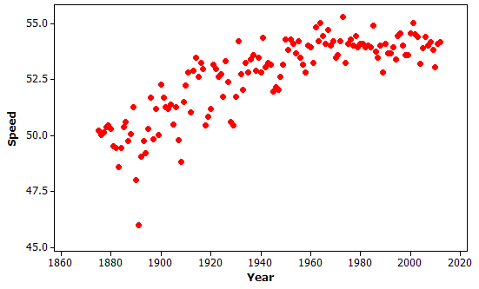

- Is the relationship between speed and year positive or negative? positive

- Is it linear or nonlinear? Explain.
Nonlinear. The points start lower on the left, but tend to curve up to the right and slightly back down at the end.

- Circle the outlier. Explain, in context, how and why the observation is unusual.
That point is unusual because it is the lowest point on the entire graph, either indicating a slower horse or faster speed (not enough info on speed to be determined). No other horse had that speed for the entire time span of the graph, 1875-2012.

- What is a line of best fit? What is it used for?
A line of fit is a line that follows the trend of the data and closely fits the data points. It is used to make predictions for data. It give expected values given the general trend of the data.

- What is the purpose of making a scatter plot of any given data?
To determine whether or not there exists a relationship between 2 sets of data.

- What kind of data is used to make a scatter plot?
Numerical, bivariate data.

- Give an example of data that would be used to make a scatter plot.
Answers will vary. EX: A monkey’s weight and height.
A car’s length and mpg
A city’s elevation and high temperature in July.

- The data below shows the average test scores in California on the standardized Reading and Math tests for 8 years.

  - Create a scatter plot to display the data.

  - Describe the nature of the relationship between the reading and math scores.
The higher the math score, the higher the reading score.

  - Draw a line of fit.

  - Use the line of fit to predict the reading score when the math score is 55.
Answers will vary. Should be somewhere between 58 and 61.

  - Write an equation for the line of fit.
Answers will vary. Slope should be somewhere around 1. Y-intercept should be somewhere around
-35.

- Sketch an example of each type of correlation.
  - Strong positive b. weak negative c. no correlation

For each scatter plot below, indicate whether it is linear or nonlinear, circle any clusters, highlight any outliers.

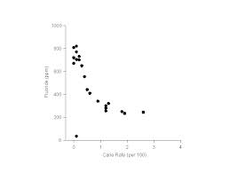
8.

nonlinear

outlier

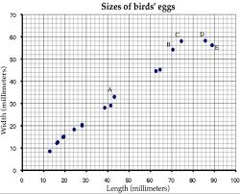
9.

nonlinear

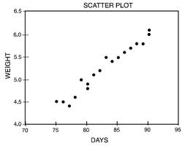
10.

linear

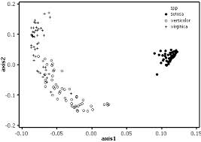
11. nonlinear

